IOT PROJECT :SMART WATER FOUNTAIN

# IBM-NAAN MUDHALVAN COURSE(Group:4)

INTERNET OF THINGS

## Done by:

## M. Madhubala (au820421106027)

## **V. Kalpana Devi (au820421106023)**

## **M. Baranika (au820421106007)**

## **K. Ashmathi (au820421106005)**

# ABSTRACT

A musical water fountain, also known as a dancing fountain , is a type of animated fountain are used to day to decorate city parks and squares ; to honor individuals or events that creates an aesthetic design. The musical fountain combines moving jets of water, sound detector, colored lights and recorded music, that controlled by a micro controller or computer, for dramatic effects. In this paper a mini and low cost musical fountain was designed using Arduino board. Arduino was used to control water valves and create interesting effects in the fountain, like pulses of water that are timed to be in synchronization with music. A transistor also used as switch to turn the fountain on and off according to the music and the particular LED will light up synchronously.

# COMPONENTS:

Arduino UNO, DC, IDE, NPN, TIP120

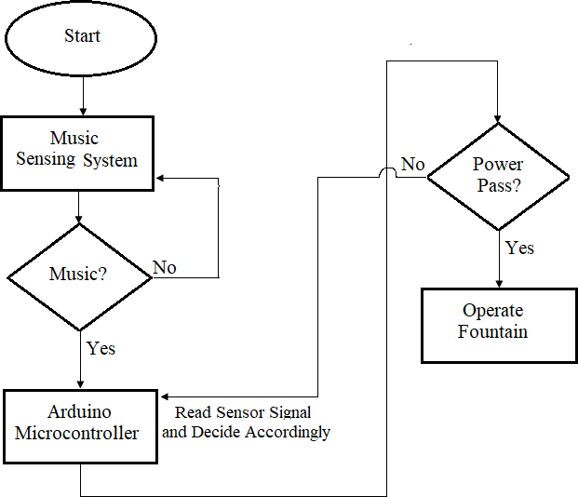

**FLOW CHART:**

**ARDUINO UNO:**

# Arduino is an open source platform that is used in many projects . It consists of a programmable circuit board (called a micro controller), as well as a programmable part of an integrated development environment (IDE ) that runs on the computer and is used to write and load code (which is a simplified version of C++) from the computer to the Arduino panel. Arduino Uno was used in this project which contains 14 digital ports (input / output) and 6 analog inputs .

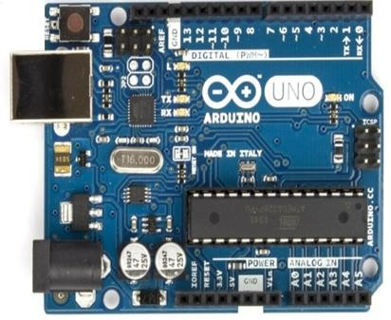

**Arduino UNO**

**TIP120 TRANSISTOR AND 1N4148 DIODE:**

TIP120 transistor is an NPN transistor; it can be used with Arduino as a fast switch and because the valves and water pump operate at 12 volt so the required voltage is higher than that Arduino can provide. TIP120 will go in between the power supply and Arduino. The use of diode is to protect TIP120 from damaging because of the high voltage. TIP120 pins and diode.

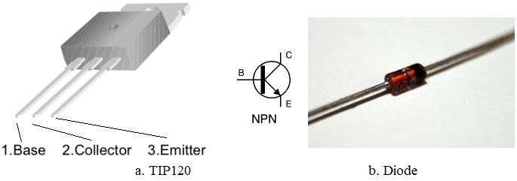

**TIP120 transistor and 1n4148 diode**

**MUSIC FOUNTAIN:**

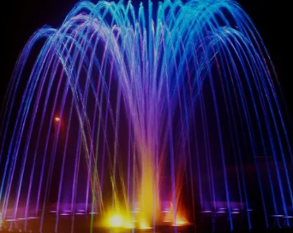

A musical fountain combines music and fountain performances to create an audio-visual artistic experience. Through precise choreography and synchronization, the changing water jets, flows, and lights correspond to the rhythm, melody, and emotions of the music, creating a stunning fusion of visual and auditory elements.

The working principle of a musical fountain involves a control system that synchronizes the music signal with elements such as water pumps, nozzles, and lighting systems.

**MUSICAL FOUNTAIN DESIGN AND PLANNING**

* Determine the purpose, location, and scale of the musical fountain.
* Fountain equipment including fountain nozzles, pumps, piping systems, underwater LED lights, cables and fountain control equipment, etc
* Consider factors such as available space, water source, power supply, and environmental before designing a musical fountain.
* Provide a design animation for checking the music fountain effect.

# CONCLUSION

In this project, a mini and cost effective musical water fountain had designed. Simple components with Arduino were used to build the design. It gave an accurate result such that it worked with any type of music and LED's gave the project more beautiful effects. The use of the transistor as a switch has made fastest response and the control of valves was very effective. This project can be used to decorate houses and offices or it can be built with larger numbers of valves with the same principles so that it can be used in shopping centers